Tactile Magnification – or 3D Printing Large Proteins

September 29, 2014, 12:15 AM, 30000ft

By Lawson Fulton

So the other day I was browsing the [Protein Database](http://www.rcsb.org/pdb/home/home.do) when I stumbled across the [Apoptosome](http://www.rcsb.org/pdb/static.do?p=education_discussion/molecule_of_the_month/pdb177_1.html). I thought, wow, that thing is beautiful, I want to touch it. Not only is it beautiful but it is also the keypin of the intricate process of cell-suicide – [Apoptosis](en.wikipedia.org/wiki/Apoptosome). Which, as gruesome as it might sound, is actually a very important piece in the prevention of cancer.

But enough of that, what I really wanted to talk about is how I went about going from this:

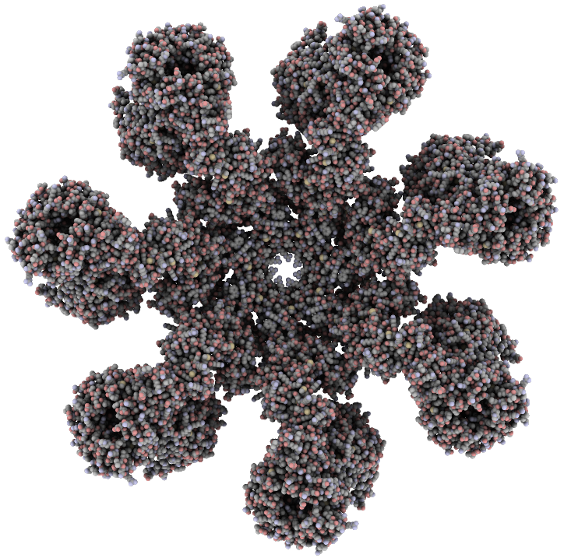

Image captured using QuteMol.

To this:

After much trial and error, I came upon a process that works. Most 3D printers use the .stl file type, which can be very difficult to create from a molecule with so much detail.

First download the .pdb file containing the protein you would like to print. The file I used is here.

Next, you will need to install [UCSF Chimera](https://www.cgl.ucsf.edu/Overview/software.html#pdbio), a fantastic application for viewing bio-molecules in a variety of display methods. It should work on OSX, Windows, and Linux. Once it is installed, launch it and open your .pdb file.

Initially you should be presented with your molecule being rendered as a ribbon diagram.

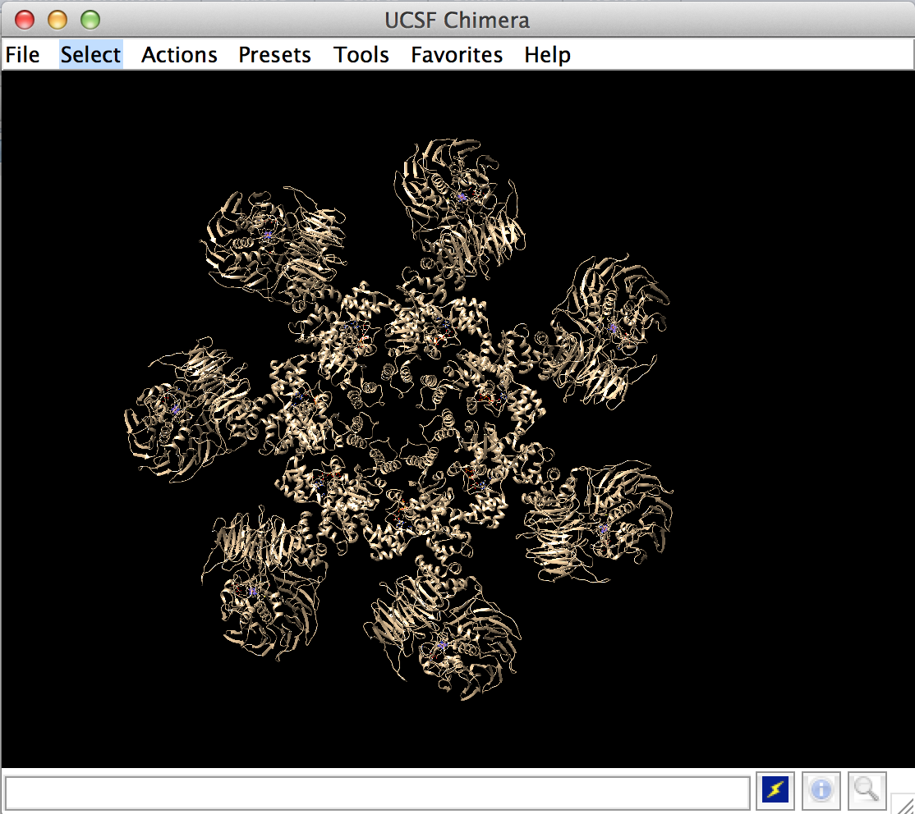

We are interested in the atomic model, so do Actions -> Ribbon -> hide, followed by Actions -> Atoms/Bonds -> show. Then switch to the sphere view by doing Actions -> Atoms/Bonds -> sphere.

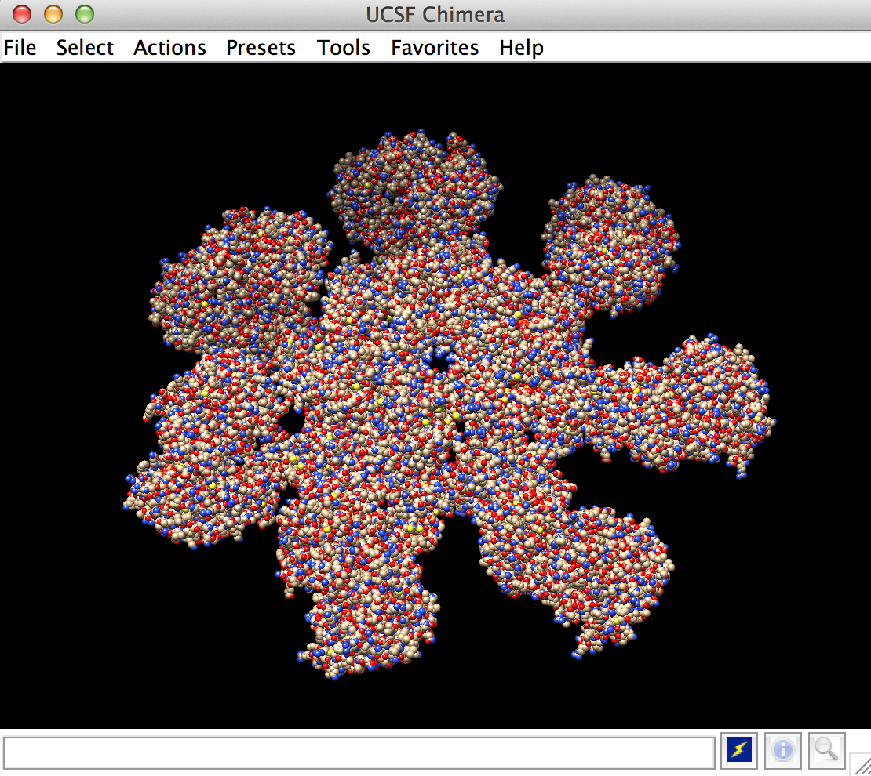

Favorites -> Command Line

molmap #0 2 cutoffRange 8 displayThreshold 0.99 sigmaFactor 0.2

Documentation here:

Actions -> Atoms/Bonds -> hide

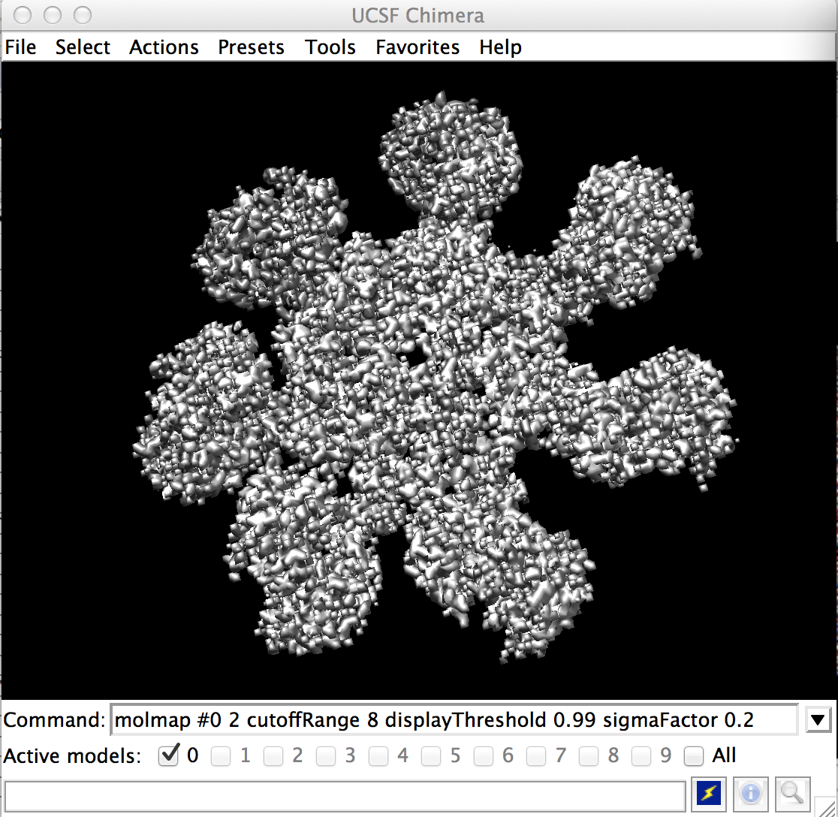

Now you can adjust the resolution to be finer.

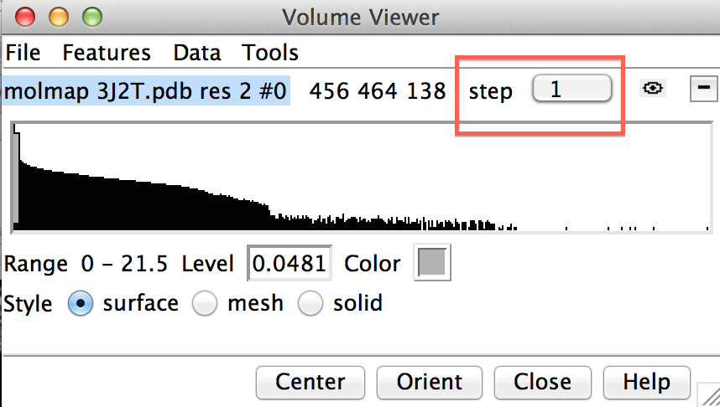

Now the mesh is fine enough to reveal individual atoms, but not so fine as to make the stl generation intractable.

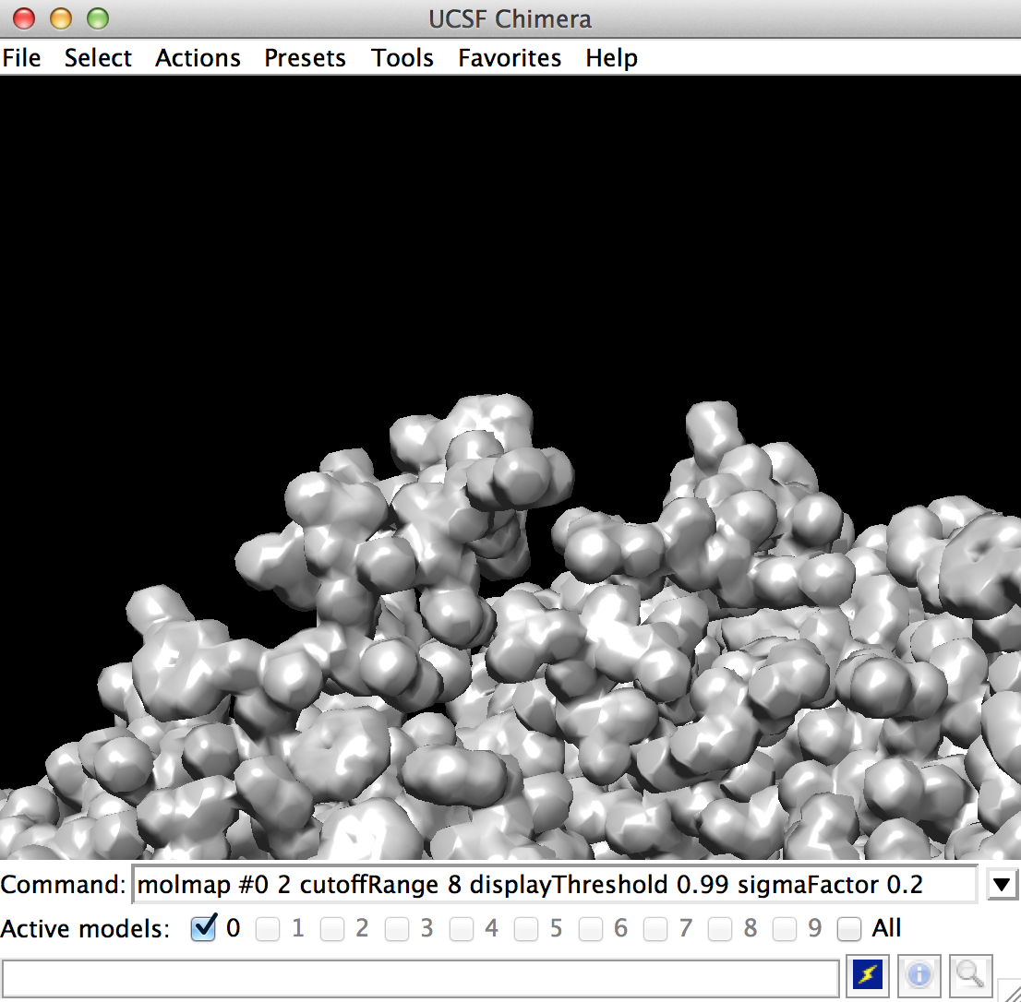

Now finally save as an stl file by going to File -> Export Scene. Make sure to change the file type to stl.

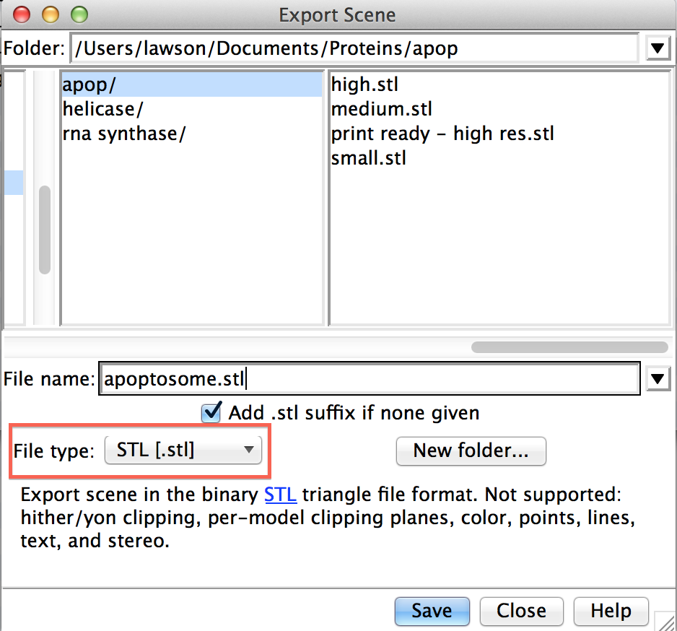

Now this part might require some patience depending on the size of your protein and the speed of your computer. For reference, it took about 20 minutes to finish running on my 2.3 GHz i7 macbook pro with 16GB memory. YMMV

Now assuming the stl export succeeded, you should have a watertight stl file ready for printing on a capable printer.

Here are my results using an Object Connex 500